***The following instructions assume you already have an AP Course Audit account, and that the AP Administrator at your school has designated you as an AP teacher for the current school year. If that is not the case, please work with your school administration to get yourself set up properly.***

1. Log into your AP Course Audit Account and select Add New Course. If you do not have an AP Course Audit account, create one by selecting Get Started - Create an Account at www.collegeboard.com/html/apcourseaudit. The APCA helpline is available for assistance at 1-877-AP-HELP-0 (877-274-3570).

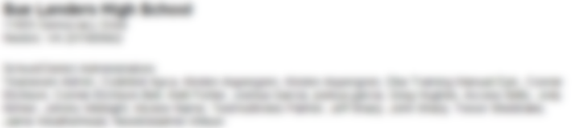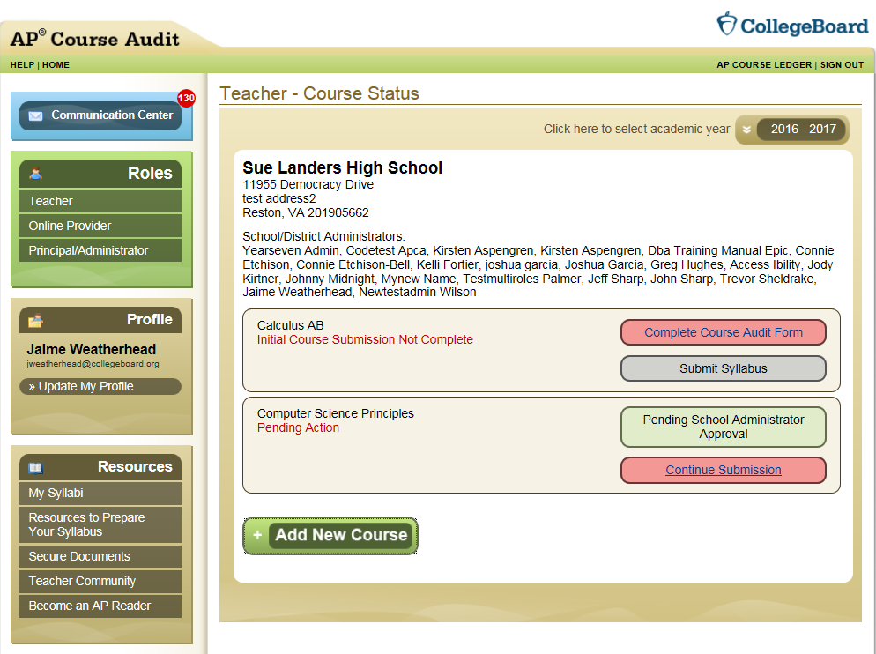

1. Choose the course you would like to add from the drop down menu. In this case you will add AP Computer Science A. Click Add Course in the pop up box. You will also need to confirm your course selection before the system will update your course listings.

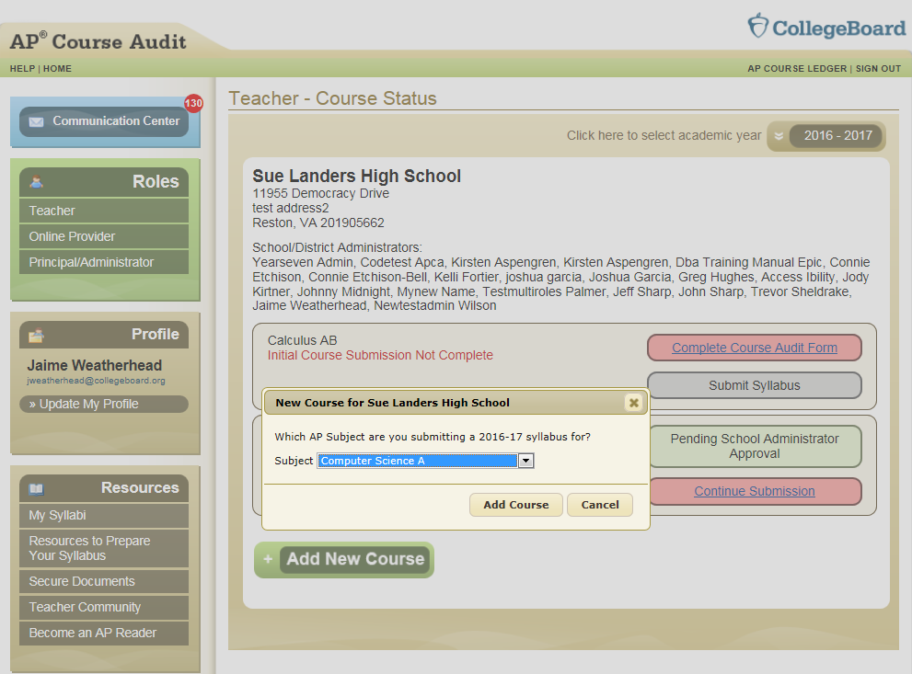

1. Now that you have added the Computer Science course to your account, you must also complete the Course Audit Form. You will need to do this before being able to submit your identical syllabus from your selected provider.

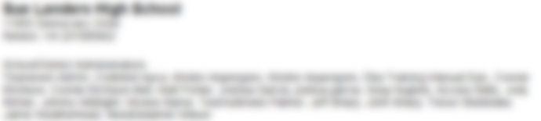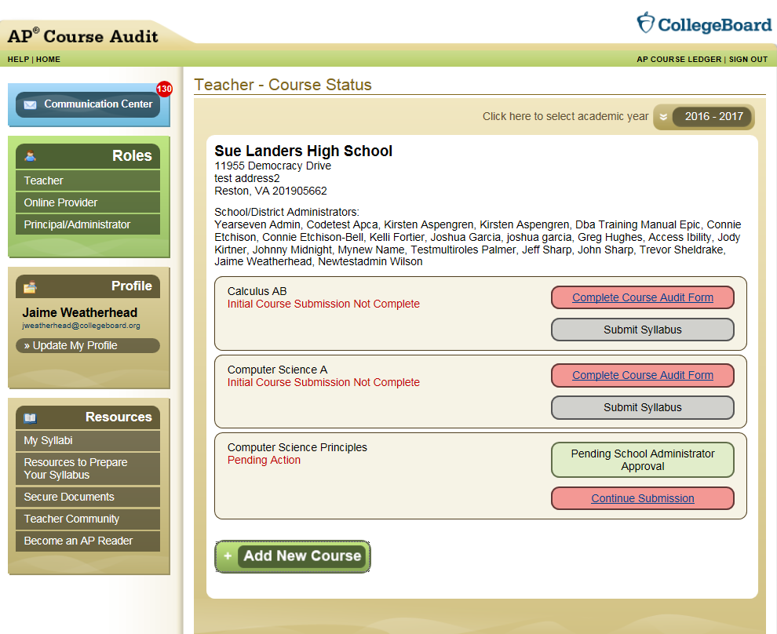

1. You must complete the form below completely, including filling in your initials. Once you’ve done this click Submit for Administrator Approval. Your school’s registered AP Administrator must finalize your submitted Course Audit form.

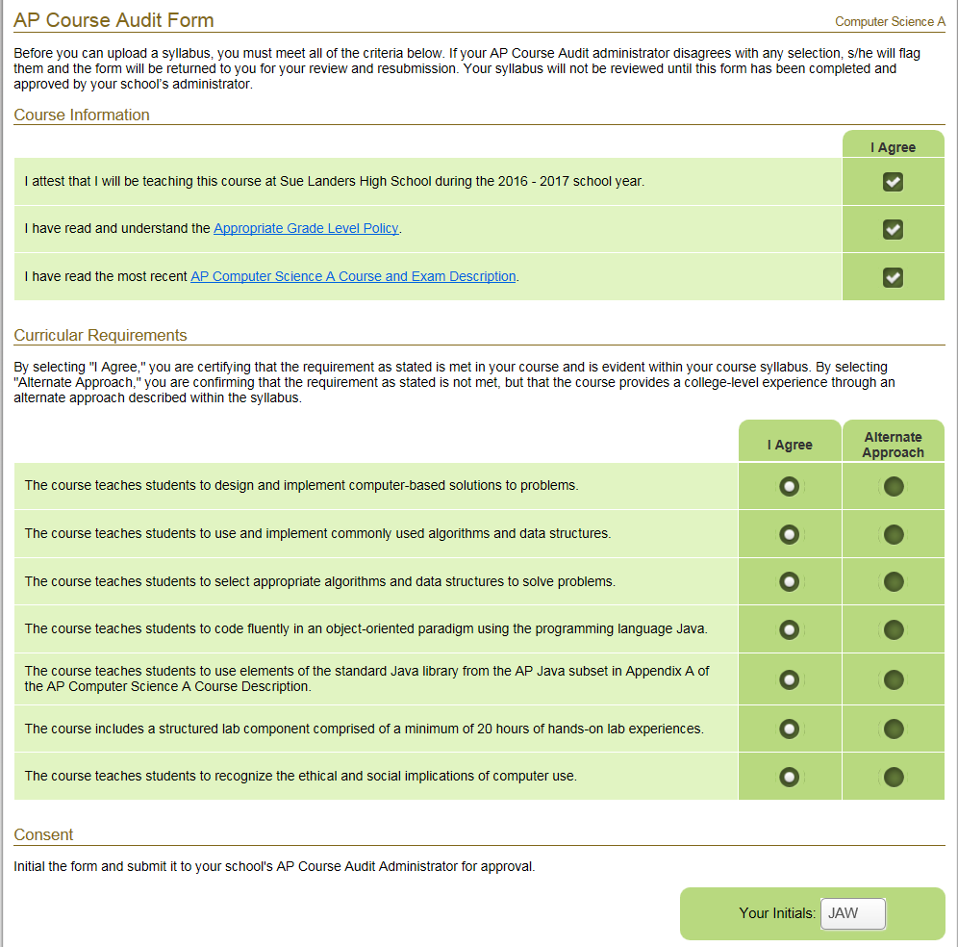



1. Now, click the red Submit Syllabus button; the system will navigate you to the next step.

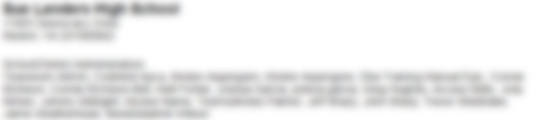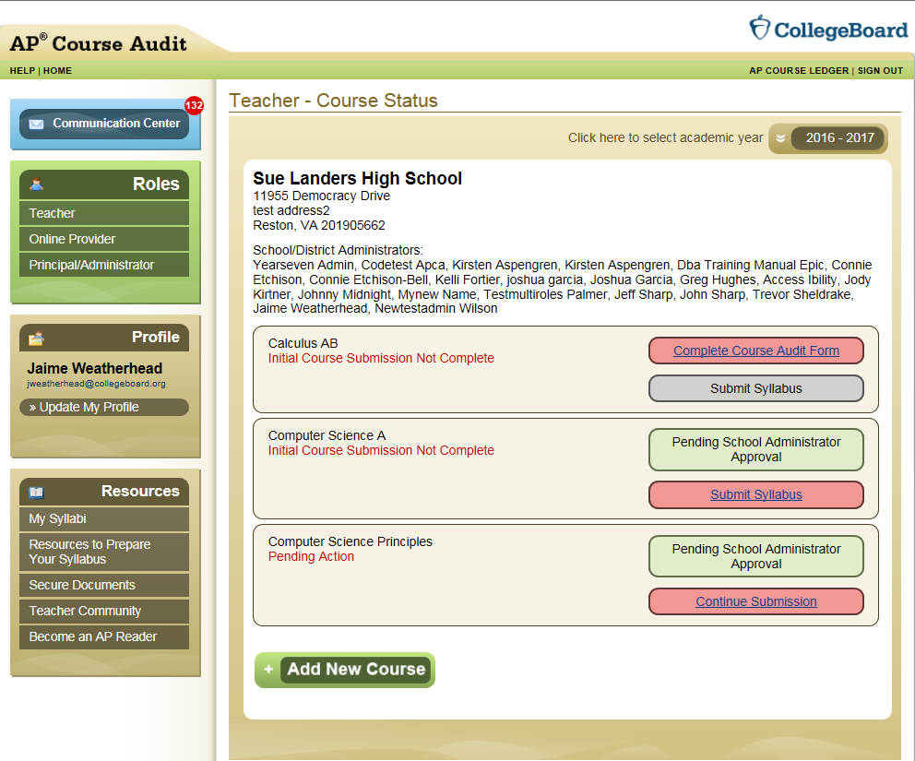

1. Select the Adopt Sample Syllabus.

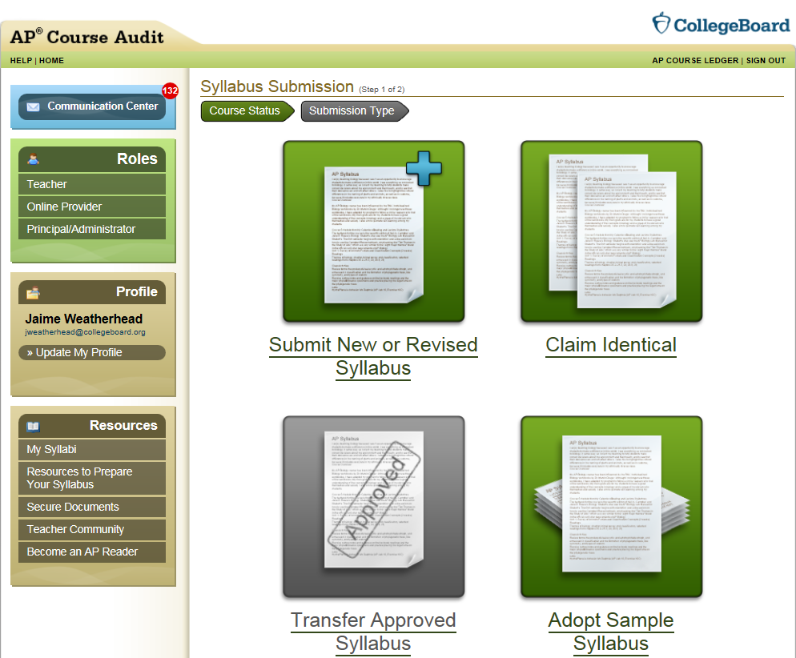

1. Select the TEALS Syllabus.

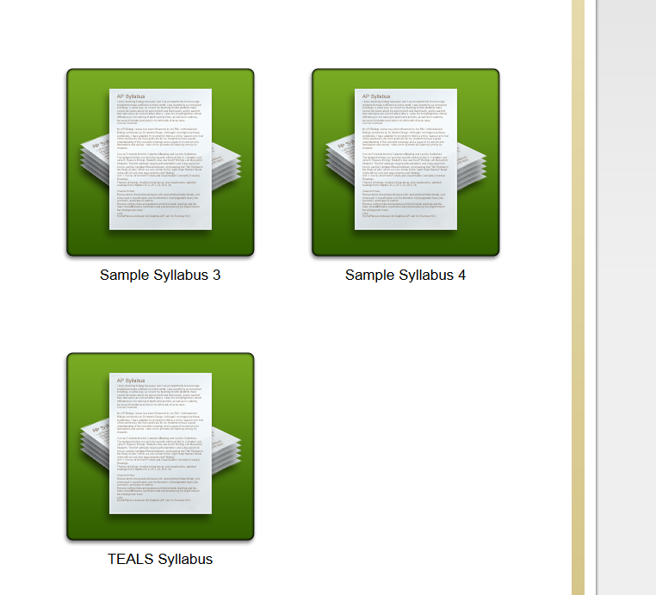

1. Once you’ve successfully downloaded your syllabus, the system will activate the Adopt Syllabus button. Click the button to complete your submission.
2. Congratulations! You’ve successfully added AP Computer Science A using the TEALS pre-approved syllabus. You will receive your review outcome within 60 days of receipt of both the submitted syllabus and the finalized Course Audit Form from your school’s registered AP Administrator.

